A.H.N. REDDAWAY
Albert Reddaway was born in Staffordshire in 1856 and moved to Cardiff as a young man where he worked as an accountant. Apart from chess he was heavily involved with the Independent Order of Good Templars, being elected the movement’s Grand Secretary.

He became involved with Cardiff chess club in the early 1890s and his abilities as an able administrator were quickly recognized. By 1894 he acted as both secretary and treasurer for the club, posts he was to retain or many years. As such he became a club delegate to the South Wales Chess Association.

From 1914 until 1928 Reddaway served as treasurer to the SWCA and he was responsible for the revival of the association after WW1. Between 1914 and 1924 he was also the elected President of SWCA. There is no doubt that he was the driving force behind the many initiatives of the SWCA between the wars which saw the association very active both in terms of individual competitions, team championships and “county” matches

He was not among their strongest players of his day and usually settled for one of the middle boards in the Cardiff team and the lower order for the association side. Nevertheless he used his skills to encourage the game and the press reported several instances where he gave simultaneous displays. For a short while in the 1920s he was chess columnist for the Glamorgan County Times.

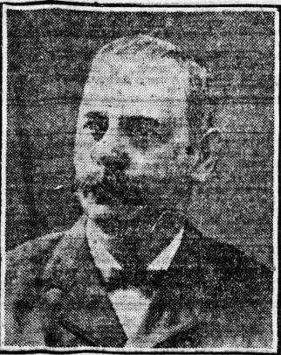

Albert Henry Nugent Reddaway
1856-1932

Welsh U15 Championship trophy in 1950s had been presented to AHNR by Cardiff chess cklub


 |  |  | 
 |  |  | 
 |  | 
 |  |  |  |  |  |  | 
 |  | 
 |  |  |  |  |  |  | 



Evening Express 1891
White to play. Mate in 2

Birth Staffordshire 1856 Albert Henry Nugent Reddaway
Married Cardiff 1878 Albert Henry N. Reddaway
Died 1932 aged 75

Playiong for Cardiff & Newport 1895 still playing for sw 1924 bd 12/27

1911 age 54 living 86 Richards Tce, Cardiff, accountant
Alice Gertrude 1894 shorthand writer and typist
Ethel Maud 1885 ditto
Florence Ethel 1891 At home
Mary Anne 1854 Pembroke married 32 years

Alice m. Cardiff 1919 Charle R. HaTField - 1920 Charle FP Hatfied b. Wansworth
Florence m. 1912 Thomas W. Mitchell --- 1914 Wm HR Mitchell b. Newport 1914

Edith M. d. 1967 aged 83 Cardiff
Mary A. d. 1932 aged 78
Florence d. Poole 1969 (b. 1890)

1957 A. Reddaway of Cardiff played bottom board for the Glorney Cup team

