Dr. J. Fine

Writing a chess history is never an easy job and it, like any other history, can never be complete. One of the frustrating aspects is that, no sooner do you finish, than fresh information comes to light. That is certainly the case with respect to Dr. J. Fine who graced the top boards of the Monmouthshire team during the 1950s. I never could get a handle on him when I was doing my research and even his first name remained unknown.

Now, thanks to the magic of the internet, it looks as though we have finally found out who he was.

Joseph Fine was born in London 1900 to Russian immigrant parents. They were a Jewish family. He seems to have moved to Glasgow at some time and went to school there, ending up in medical college at Glasgow University and graduating as a doctor. He intended to become a pathologist but his plans were interrupted by the Second World War and he was posted to Palestine, to serve as a doctor with the Middle East Force.

Following the war he finally became a pathologist and in 1948 he was made Chief Pathologist at the Royal Gwent Hospital in Newport. This was the time when he was introduced to chess in Newport and won the county Championship 1948, 50, 51, 56 (joint) and 57; and the Newport Club Championship 1949 and 1955. He played on top board for the county for most of this time. In 1963 he disappeared from the South Wales record books and this was because of a move to Zimbabwe where he ran a pathology unit. Joseph Fine died about 1988. His widow moved back to Britain and died at Hove in 1998 aged 100.

One of the puzzles was where he played his chess before coming to Wales. He was a very strong player who unfortunately never tested himself in the Welsh Championships, but he must have been playing chess at a high standard before 1948. The Scottish Chess website records him playing on Board 2 for Glasgow Jewish Institute when they won the Scvottish Club Championships – the Spens Cup – in 1927, but his chess career before and after that date remains a mystery.
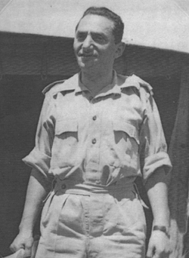

Dr. Joseph Fine in Palestine

