MAJOR GENERAL HENRY H. LEE

Major General Lee is mentioned in “Chess In Wales”* as serving as President of the fledgling South Wales Chess Association 1893-4.

In his retirement he lived in Dinas Powis and was a member of the Cardiff Chess Club being rated as one of their first class players.

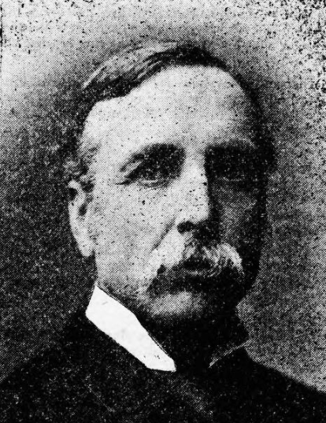
Major General H.H.Lee in 1892

In a very active career he accompanied General Napier to Abyssinia in 1868 and in 1885 was with Lord Wolsley in Egypt. He also worked in India for many years.

He retired from the army in 1886. His family were from The Mount, Dinas Powis and that is where he then settled. He continued to be extremely active in civil affairs including acting as Commissioner for the new scouts’ movement. In one biographical account he listed his chief recreational interests as, “chess playing, music, and writing cheques for charitable objects!”

His interest in all things military also continued and he was honorary colonel of the “Submarine Miners”. The miracle is that he found time to play any chess at all given that his list of duties included: member of the Local Board, Vice-Chairman of the School Board, local magistrate, treasurer of the Barry Nursing Association, member of the Dinas Powis Highway Board, member of the Rural Sanitary Authority, and President of the Dinas Powis Horticultural Society.

The fact that he was President of S.W.C.A. for only one year might suggest that his was a stop-gap presidency, wedged between the longer periods enjoyed by Lord Aberdare and Lord Rhondda. These early presidents not only gave their name to promote chess events but also gave financial support. General Lee’s interest in organized chess did not wane; after the election of D.A.Thomas M.P. (later Lord Rhondda), he continued in office as Vice-President; and in 1896 he is recorded as Vice-President of the new Barry Chess Club. He also continued as one of the senior members of Cardiff Chess Club. He died in 1920 aged 81.

*Chess in Wales is still available through Moravian Press.

