WELSH CHESS UNION

It was really no surprise that chess in Wales moved towards a union in 1954. Full employment and improved working practices including more leisure time, meant that there was more time and money to indulge in hobbies and pastimes such as chess.

After the Great War there was a surge of interest in chess in the Principality and a great increase in activities with leagues such as the Central League and the Borders League being created. However, any optimism that existed was quickly extinguished in the years following the General Strike when the Depression took hold.

The original aim of creating a ‘union’ was to fall in line with other parts of the British Chess Federation which operated as combined county unions representing, South, North, West, Midlands etc… Really the main effect that the creation of a Welsh Chess Union had was to establish a national identity which eventually saw fruition in the independence of Wales from the British Chess Federation in 1970. Ironically this was something that the founder, Henry Golding, was strongly against.

In November 1953 the executive councils of the South Wales Chess Union (the name had recently been altered from ‘Federation’ and before that ‘Association’) and the Monmouthshire County Chess Association agreed on the principle of a Welsh Chess Union. A joint committee was formed

What was surprising was that it was not the Welsh born, Welsh bred players who clammered for greater national recognition, but rather players born outside Wales who moved to Wales to follow their employment.

Henry Golding, F.S. Wayling and Joe Lang were the three persons who claimed the idea of a Welsh Chess Union as their own. Outside the individual clubs there was no organisation of chess in Wales beyond South Wales and it would be five years before Mid Wales joined the Union, North Wales making the final constituent two years later.

Frederick Sharpe Wayling (1896-1972) was a native of London and was extremely active in the establishment of a Welsh Chess Union as well as instigating the East Glamorgan Chess League. By 1957 he had retired to St. Austell in Cornwall.

Joe Lang joined Cardiff in 1934. His real name was Josef Primich. He was never an organiser of the game but was a strong player for many years and played in the Cardiff area for over 40 years.

Henry Golding modestly described himself as “the architect of the Welsh Chess Union”. There is no doubt that he and Wayling were the two most influential characters in the creation of the WCU. His profile already appears on the WCU website.

The establishment of a union immediately saw the inauguration of a national championship. This was something that had been talked about for about 80 years but which had never been attempted before.

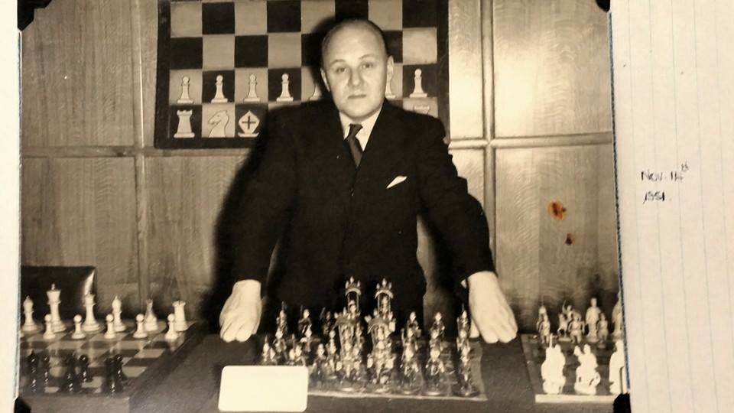

Henry Golding with his collection of chess sets.

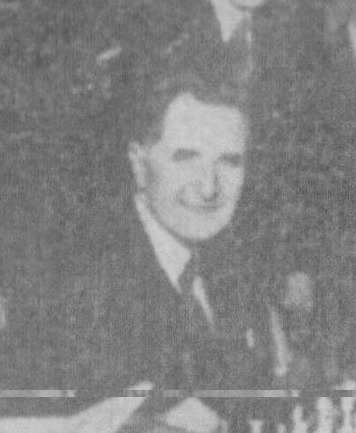

T.C.Hughes, the long-serving secretary of the South Wales Chess
Association, was the man who officially proposed the formation of the Welsh Chess union.

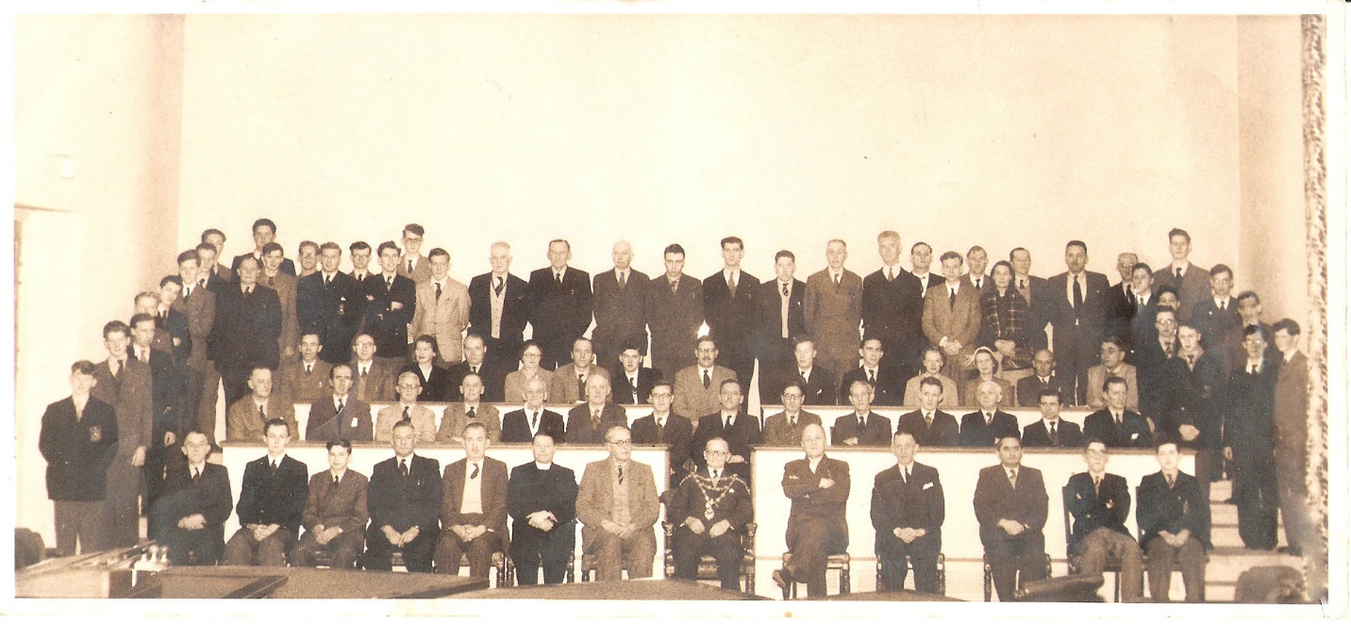
The Monmouthshire v. East Glamorgan match 8th January 1955.
The first county match within the new Union.

