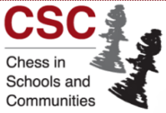 | Chess Tutor  Training Course

Chess in Schools and Communities (CSC) are running a
Chess Tutor Training Course
at the
Park Inn by Radisson, Mary Ann Street, Cardiff
on
Saturday 21 May 10am to 4pm.

The course is aimed at chess players, teachers, teaching assistants, parents and anyone already involved or who would like to get involved in school or junior chess. No teaching or chess playing experience is required to attend

The course will cover:
- Benefits of chess
- Primary school CSC chess syllabus - an overview
- Cross-curricular links
- Techniques for teaching chess
- Chess sub-games and variants
- Running a school chess club
- Resources and materials
- Pieces, moves, captures, checks and checkmates – practical

The course is £60 for the day but free to those already involved in CSC school chess.

For more information talk to Sarah or Timothy Kett, or go to the CSC website.
https://www.chessinschools.co.uk/Pages/Events/Category/new-tutor-training-courses

