GLORNEY CUP
1949-2024
by
Martyn J. Griffiths

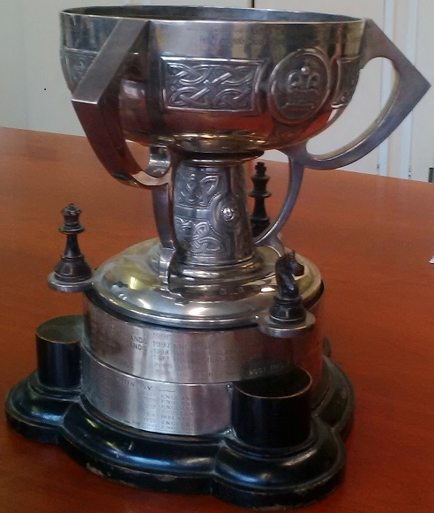
The original Glorney Cup

This year it is 75 years since Wales first played in the Glorney Cup. Many fine players have represented their country during that time; some, like Leighton Williams and Richard Jones, going on to become International Masters; others like Walter Marshall and Keith Peters, giving up the game but becoming pillars of industry or renown academics. The fact that we have never won the Cup is almost immaterial. Hundreds of youngsters have learned the game to a high standard and should all be proud of the fact that they have represented their country. Wales finished runners-up in 1952, 1958, 1959, 1960 and 2012.
The Glorney Cup was originally a competition for boys under 19 years of age and is now limited to players (boys and girls) under 18 years of age on 1st January of the year in which the event takes place. The first competition was held in 1948 between England and Ireland battling for a cup donated by Mr Cecil Parker Glorney of Dublin. Wales joined a year later and Scotland in 1951.
Brother Cyril of St. Illtyd’s College in Cardiff was in charge of the Welsh team until 1960. He single-handedly kick-started junior chess in Wales by forming the Welsh Secondary Schools Chess Association in 1950 and promoting various junior competitions. A special blazer badge was designed for the Welsh team with the motto, ‘Immoti Movemus’ which means ‘Unmoved We Move’. Graham Roblin of Brecon took over from Brother Cyril but since 1970 Ian Eustis of Swansea has been in charge. In 1991 he was selected to succeed Ken Bloodworth as secretary for the whole event.
The original invitation for Wales to compete in 1949 was sent to Mr. D. Ll. Jones of Barry by the Chess Education Society. This he forwarded to the South Wales Chess Association who immediately took up the gauntlet and sent out invitations to all clubs and to all schools where chess was known to be played:- St. Illtyd’s College Cardiff, Cardiff High School, Swansea G.S., Llanelli G.S., Bargoed G.S., Caerphilly G.S., Llandrindod County, Knighton County, Pontardawe G.S., and Port Talbot County. Not one senior club replied offering a player! Four of the schools, St. Illtyd’s, Llanelli, Swansea and Port Talbot replied and the University of Wales also put forward a candidate, Stephen. Usher (who was born in Swansea). That event was held in Birmingham and today the tournament travels to a different nation every year.
The Glorney became a six-nation event for the first time in 1964. The Faber Cup for girls of the same age was first played in 1968 and this later became known as the Gilbert Cup.
Rhiannon Hammond (2001) was the first girl to play in the Welsh Glorney Cup team. The 2020 competition was played on-line due to covid.
The competition was added to in 2007 when the Robinson Cup (Under 14) and Stokes Cup (Under 12) were competed for. The tournament now comprises four team competitions and takes place at the end of July every year.
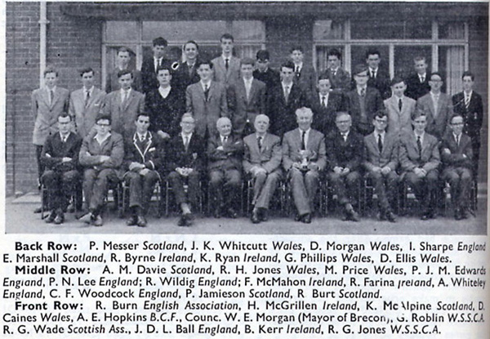
There are very few photos of Welsh teams where players can be identified. This was taken when the event was played in Brecon in 1962 and is taken from ‘Chess’ magazine.
This is a list of all the players who have represented Wales together with their club or town of origin:
Philip D. Alder 1967, 1968, 1969 Newport
Anthony Anderson 1978, 1979, 1980, 1981 Newport
Chris Arnold 2003, 2004 Newport
A. R. John Arthur 1958 Newport
Paul Atkinson 1987, 1988, 1989, 1990, 1991 Newport
Ian Bacon 1992 Cheltenham
James Baker 2015 Monmouth
Ian Barclay 1976, 1977, 1978 Rhondda
J. Hagan P. Bayley 1967 Rhyl
Patrick J. Bennett 1958, 1959, 1960 Cardiff
Jonathon Blackburn 1998, 1999, 2000, 2003 Grappenhall
Michael Blakemore 1994, 1995 Monmouth
Colin M. Bloodworth 1957, 1958, 1959 Pontypridd
Jonathon Bold 2011, 2012 Cardiff
Paul Botto 1973, 1974, 1975, 1976, 1977 Swansea
Christopher A. Boyd 1975, 1976, 1977, 1978 Cardiff
Gerald M. Brace 1967 Newport
David Bray 1970 Cwmbran
Anthony Brown 1978, 1979 Newport
Frederick Brown 1984, 1985 Cwmbran
Tomas Brown 1993 Cardiff
Patrick D. Bryon 1955, 1956 Cardiff
Andrew Bucknell 2007 Newport
Alex Bullen 2009, 2010 Cardiff
Igor Burenkov 2001 Cardiff
Slava Burenkov 2002 Cardiff
Brian F. Burows 1950, 1951, 1952, 1953 Bridgend
David A. Caines 1962 Newport
Aron Calist 2016 Cardiff
Iwan Cave 2024 Romsey, Hants.
Imogen Camp 2017, 2018, 2019 Colwyn Bay
Daniel Chung 2023 Swansea
Joel Chung 2020, 2021, 2023 Swansea
Richard Cleveland 1996, 1997, 1998 Swansea
David Cleverly 2007, 2008, 2009, 2010 Swansea
Neil Clifford 1978 Swansea
J. A. Cohen 1950, 1951 Cardiff
John G. Cooper 1972 Cardiff
Stephen Cordy 1990 Caerphilly
Stephen K. Cronick 1968, 1969, 1970 Cardiff
Philip Cunningham 1976 Newport
Peter Czerniewski 1967 Llandyssul
Roshan Daniel 2010 Swansea
Mark Darlington 1980 Barry
Peter Daughton 1959, 1960 Cardiff
Anthony J. Davies 1954, 1955, 1956 Swansea
Christopher Davies 1998, 1999 , 2000 Bishop Vaughan
Carl Davies 2005, 2006, 2007, 2008, 2009 Neath
John S. Davies 1964 Merthyr
Merlin Davies 2020, 2023 Daventry
Peter L. Davies 1968, 1969, 1971 Cardiff
W. Vivian Davies 1964, 1965, 1966 Llanelli
Ashley Davis 2010, 2011, 2012 Barry
Robert J. Deakin 1954 Cardiff
Ronald G. Denning 1957, 1958, 1959 Cardiff
Christopher Dixon 1974 Cwmbran
Andrew Dyce 1994, 1995, 1996, 1997 Sutton
David Ellis 1961, 1962, 1963 Newport
Christopher B. Evans 1970 Caerphilly
David K. Evans 1977 Bridgend
Howard P. Evans 1958 Cardiff
James Evans 2016, 2018 Llanelli
John M. Evans 1966 Cardiff
Mark Evans 1989 Neath
Nicholas Evans 2013, 2014, 2015 Llanelli
Mark Fell 1974 Swansea
Andrew Fish 1991, 1992, 1993 Cardiff
Brian E. Foan 1952, 1953 Cardiff
Brian Foster 1952 Newport
David G. Flower 1977, 1979 Haverfordwest
Caspian Fowler 2018, 2021 Street
Hugo Fowler 2017, 2018, 2019, 2020 Street
Christopher E. Franklin 1970, 1971 Cardiff
Jeremy Franklin 1972 Cardiff
Alex Freeland 2010, 2011, 2012 Cardiff
Jonathon Gilbert 1985, 1986 Cwmbran
William Gough 1956 Cardiff
Michael Gronow 1955 Cardiff
Chirag Guha 2019, 2020, 2022 Sutton Coldfield
Geoffrey T. Haigh 1968, 1969, 1970 Cwmbran
Rhiannon Hammond 2001 Swansea Valley
John Hardie 2002 Cardiff
Paul Hatchett 1982 Haverfordwest
Peter Heaven 1980, 1981 Tunbridge Wells
Hans Hermann 1973 Cardiff
John R. Holland 1957 Cwm
G. Hopkins 1960, 1961 Bridgend
Ian R. Hopkins 1960 Merthyr
Michel Hosseini 2008 Cardiff
Alan J. Hughes 1965, 1966 Cardiff
Anthony G. Hughes 1963 Cardiff
Gareth Hughes 1995, 1996, 1997 Cardiff
David Hunt 1996 Cardiff
Gian Illari 1987, 1988, 1989, 1990, 1991 Merthyr
Nathaniel Inskip 2004, 2005 Newcastle Emlyn
Daniel Jaberanseri 2018, 2021 Caerphilly
David James 1969, 1970 Cwmbran
Stephen C. James 1978, 1979, 1980, 1981 Lightwater
Simon James 1979, 1980, 198 2 Newport
Stephen Jenkins 1972 Merthyr
John A. John 1959 Aberystwyth
Gruffydd Johnston 2003 Carmarthen
Andrew R. Jones 1987, 1988, 1989, 1990, 1991, 1992 Caerphilly
D. Rowe Jones 1951 Bridgend
Gareth A. Jones 1963, 1964 Cardiff
Graham T. D. Jones 1949 Llanelli
J. Graham T. Jones 1949, 1950, 1951 Port Talbot
Michael G. Jones 1953 Aberdare
Russell Jones 1977 Newport
Richard G. Jones 1960, 1961 Aberdare
Robert H. Jones 1962 Newport
Richard S. Jones 1996, 1997, 1998, 1999, 2000 Swansea Valley
Brian D. Josephson 1956 Cardiff
Alex Kent 2005 Monmouth
Larry Khana 2006 Cardiff
Perry Khana 2005, 2006 Cardiff
Luke Kostanjek 2012, 2013 Newport
Paul Lamford 1971 Llanelli
Karanvir Latchman-Singh 2017 Penarth
Jonathon Leinmuller 1993 Monmouth
David Lewis 1973 ` Cwmbran
Michael J. Lexton 1966 Cardiff
Trystan Lloyd 2007 Connah’s Quay
Matthew Long 1984, 1985, 1986, 1987, 1988 Swansea
David Lovell 2005 Rhondda
Duncan MacDonald 2020, 2021, 2022 North Cardiff
Elliot MacNeill 2014 Cardiff
Terence B. Marsden 1949 Swansea
Peter K. Marshall 1950, 1951, 1952 Cardiff
Walter Marshall 1949, 1950 Cardiff
David Martin 1993, 1994, 1995 Haverfordwest
Ian Maxwell 1980, 1982, 1983, 1984 Swansea
Ethan McGrath 2024 Pentyrch
David McIntosh 2019 Chepstow
Michael J. Mears 1956, 1957, 1958 Cardiff
Davin Menon 2009, 2010, 2011, 2012 Wrexham
Chris Michael 1959 Cardiff
Richard J. Miles 1966, 1967, 1968 Newport
George E. Moon 1961 Cardiff
J. Dylan Morgan 1962, 1963, 1964 Aberdare
Robert Morton 1992 Bridgend
Herbert Mueller 1963, 1964 Merthyr
John Murphy 1949 Cardiff
Adam Musson 1989 Neath
Michael J. Neary 1971 Cardiff
Guto Neave 2016 Llanelli
Frank Norman 1974, 1975 Cardiff
Howard J. O’Brien 1965 Cardiff
Timothy V. O’Leary 1971 Cardiff
Paul O’Neill 1983, 1984 Merthyr
David Osborne 1972 Penarth
Michael G. Parsons 1952, 1953 Newport
Gareth D. Pearce 1971 Abingdon
Christopher R. Perry 1950 Cardiff
Phillip M. Perry 1954, 1955, 1956, 1957 Cardiff
D. Keith Peters 1953, 1954, 1955 Port Talbot
Petko Petkov 2017 Colwyn Bay
Graham Phillips 1962 Llanelli
Owen S. Phillips 1977 Cwmbran
Andrew Ponting 1989, 1990, 1991 Frome
Martin Price 1961, 1962 Newport
Kristian Prosser 2015 Cardiff
Ifan Rathbone-Jones 2019, 2021, 2022 Deeside
Emanuel Rayner 1974, 1975, 1976 Merthyr
Anthony Reddaway 1957 Cardiff
Ioan Rees 2001, 2002, 2003, 2004 Caerphilly
R. A. Rees 1954 Cardiff
K. Reynolds 1960 Cardiff
Tudor Rickard 1958, 1959, 1960 Pontypridd
Nasir Rizvi 1992, 1994 Swansea
David L. Roberts 1974 Cardiff
Phillippe Rodgers 2009, 2013, 2014 Bishop Vaughan
John Roe 1995 Monmouth
Oliver Sapsford 2023 Chepstow
Mark Saunders 1986 Neath
Robert Saunders 1983, 1984, 1985 Neath
Roy Scammell 1961 Newtown
Jeffrey Scholey 1993 Monmouth
Mateusz Siedusewski 2014 Swansea
James Silk 2007 Neath
Christopher Sims 1985, 1986 Neath
Ayush Singh 2021 Cardiff
Callum Smith 2020 Cardiff
Ellison Smith 2022, 2024 North Cardiff
George Smith 2016 Chepstow
Jeffrey R. Smith 1979, 1980, 1981, 1982 Caerphilly
Madeleine Smith 2020 Chepstow
Richard L. Smith 1970, 1971 Cardiff
Douglas Spencer 2000, 2001, 2002, 2003 Abergavenny
Rees Steele 2013 Barry
Ernest D. Stephens 1953 Cwmfelinfach
Anthony St. Clair 1978 Barry
Jason Sullivan 1985 Merthyr
Walter B. Sullivan 1953, 1955 Cardiff
David J. Sully 1965 Cardiff
John E. Syner 1966, 1967 Cwmbran
Bence Szakmany 2022, 2023, 2024 North Cardiff
John Tabatabai 1999, 2001, 2002 Cardiff
A. C. Thomas 1951 Cardiff
Andrew M. Thomas 1988 Swansea
Ben Thomas 2015, 2016, 2017 Penarth
Jac Thomas 2004, 2006,2008, 2009, 2010 Monmouth
James Thomas 2009, 2010 Penarth
Joseff Thomas 2004, 2006 Monmouth
Philip A. Thomas 1964, 1965 Newport
Richard Thomas 1982, 1983 Swansea
Thomas Thorpe 2011, 2012, 2013, 2014 Bristol
David Tomboline 1979 Pennard
Clive Trevelyan 1973, 1974, 1975, 1976 Bridgend
Brian B. Trott 1954 Cardiff
Ian D. Turner 1968 Cardiff
Stephen Usher 1949 Swansea
Peter Varley 1975 Newport
David O. Vaughan 1969 Cwmbran
Andrew Walden-Jones 1997, 1998, 1999, 2000 Cardigan
Christopher Walsh 1986, 1987, 1988, 1989, 1990 Neath
Stuart Warner 1975 Haverfordwest
John Waters 1976 Newport
Mark Watkins 1981, 1982, 1983, 1984 Pontardulais
Tim Wegener 1986 Caerphilly
Paul Wentworth 1954 Cardiff
John K. Whitcutt 1961, 1962, 1963, 1964 Newport
Ian G. White 1972, 1973 Pontypool
Francis I. Whitehouse 1969 Llandyssul
A. Howard Williams 1965, 1966, 1967, 1968 Cowbridge
Kevin D. Williams 1972, 1973 Cardiff
Leighton Williams 1994 Abercynon
Michael J. Williams 1952 Newport
Paul E. Williams 1972, 1973 Cwmbran
Peter V. Williams 1951, 1952 Cardiff
Jonathon Wood 1987 Bridgend
Robert E. Wood 1965 Tredegar
Yuxuan Wu 2022, 2024 Cardiff
Frederick S. Wusteman 1955, 1956, 1957 Cardiff
Alan Xiao 2008 Upper Killay
Alan Young 1983 Llanelli

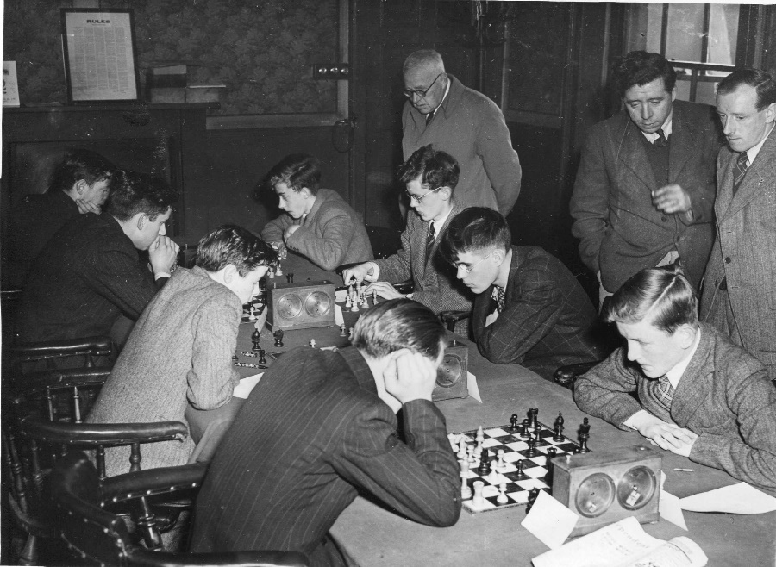

Wales, with their backs to the camera, play Ireland in their first
Glorney adventure 1949 in Dublin.
Walter Marshall is closest to the camera.

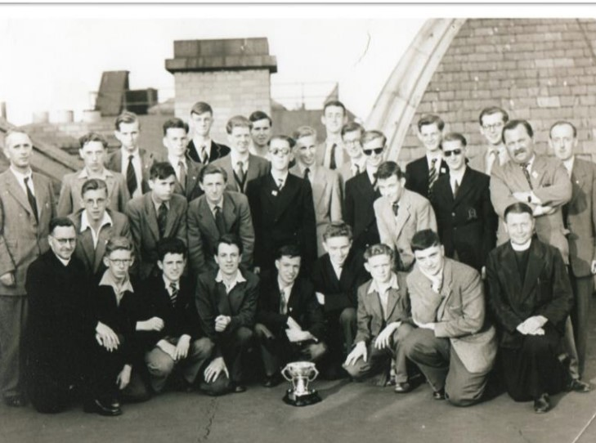

The 1955 teams from England, Scotland, Wales and Ireland in Dublin.

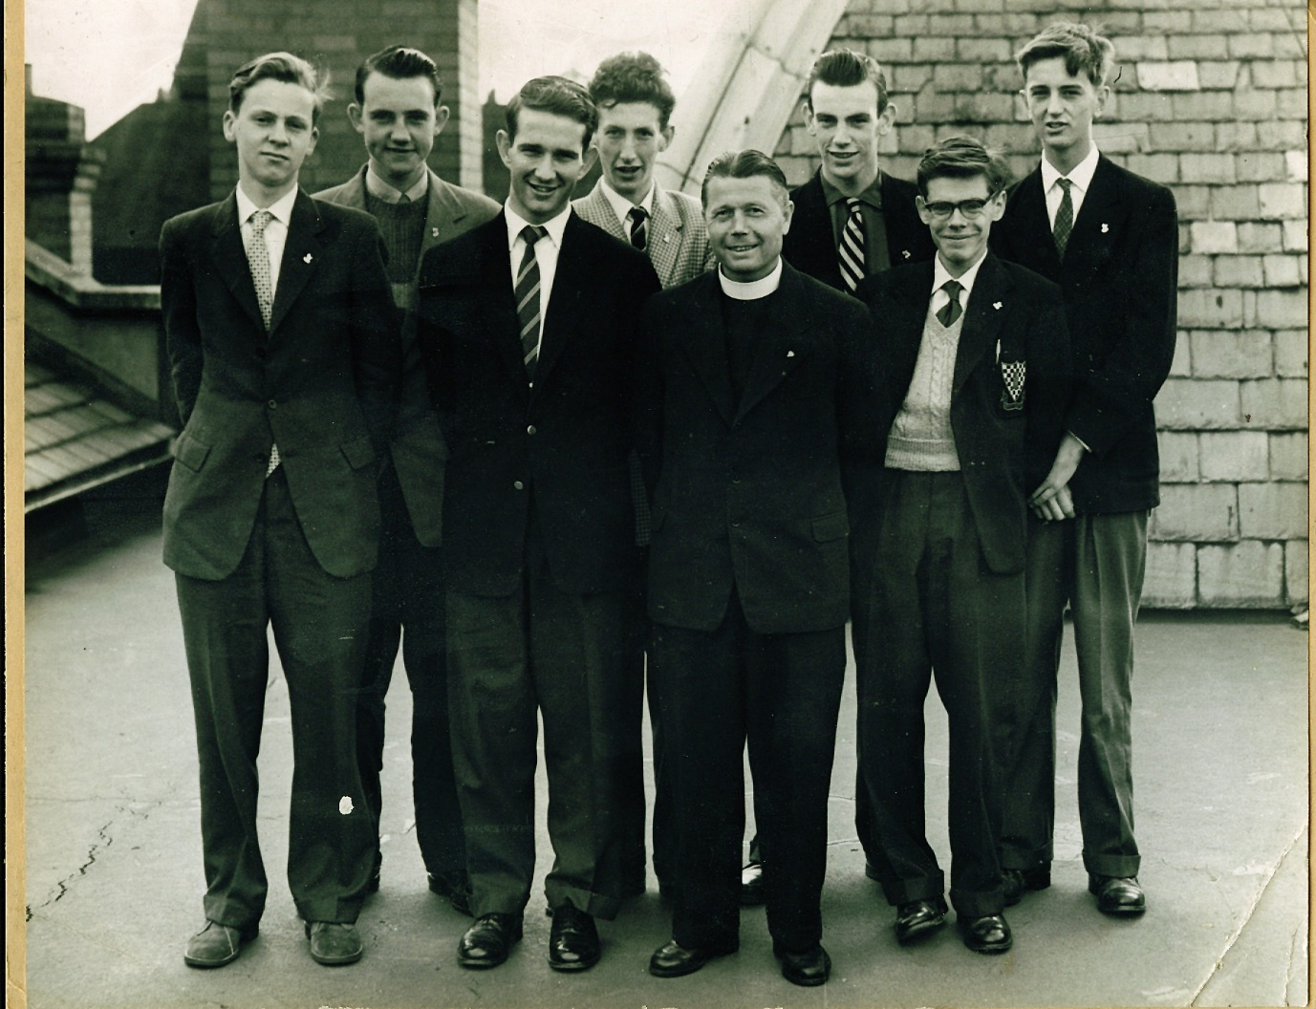
1959 Welsh team in Dublin
Back Row L-R: Peter Daughton, Colin Bloodworth, Pat Bennett, John John
Front row - Chris Michael, Ronald Denning, Brother Cyril and Tudor Rickard

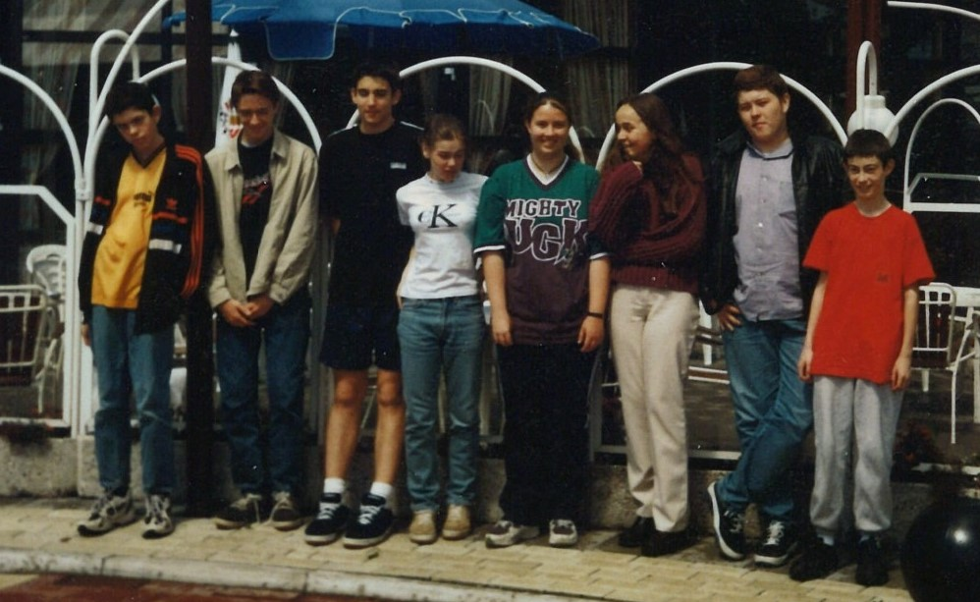

The 1998 Glorney and Faber teams ready to compete in the Netherlands.
From the left: Richad S. Jones, Andrew Waldon-Jones, Christopher Davies, Annie Powell, Rhiannon Hammond, Helen Gale, Richard Cleveland, Jonathon Blackburn.

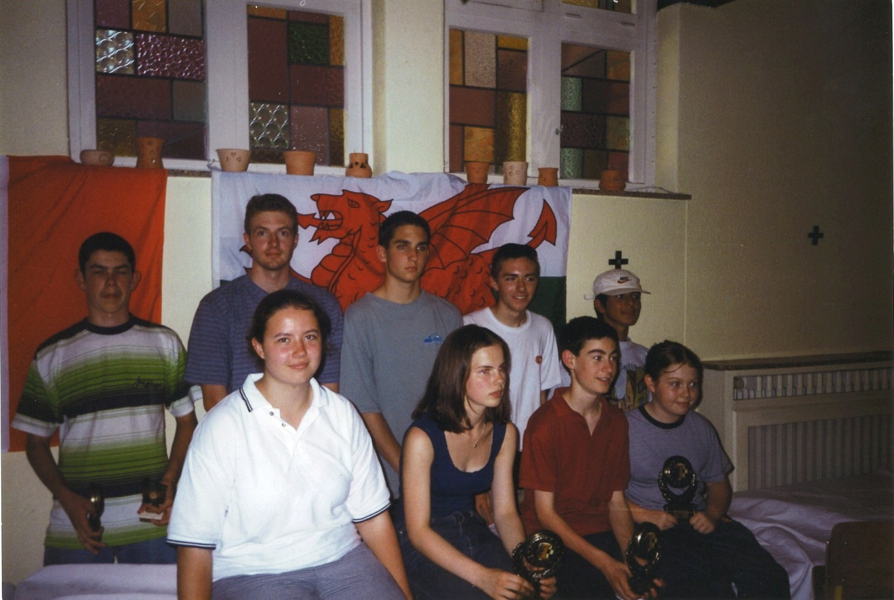

1999 and almost the identical teams are this time in Belgium
Back row: Richard S. Jones, Andrew Dyce (coach), Christopher Davies,
Andrew Waldon-Jones, John Tabatabai
Front row : Rhiannon Hammond, Annie Powell, Jonathon Blackburn, Suzie Blackburn.

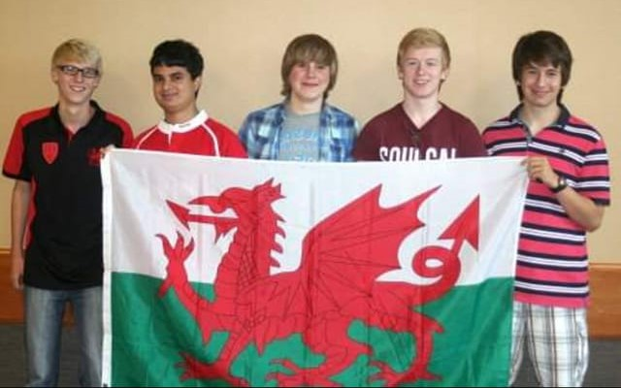

Wales were runners-up at Daventry in 2012
L-R : Alex Bullen, Davin Menon, Luke Kostanjek, James Thomas and Phillippe Rodgers.

Some may wonder why Wales has never been successful in these events. The Welsh teams have always been out-graded; indeed, if trophies were decided purely on grades, England would have won almost every year. There is no doubt that the main reason for the lack of success is numbers. There is a much smaller pool of young players in Wales than in England, (all) Ireland or Scotland. There have been ten years where Wales could not even put together a three-board girls’ team for the Faber and Gilbert trophies. Sickness, holidays, and competing chess events have all diminished the small Welsh pool of players and some of those who took part would not have been in the team if a full complement had been available. Nevertheless, over 300 children have experienced the ups and downs of playing for their country and each and every one of them benefitted from taking part.
The question remains, how do we achieve that illusive success? Certainly, we need to broaden our base and do more to encourage chess amongst children both in schools and in clubs. At the other end of the spectrum, there is a need for enhanced elite training, perhaps on-line, for all age-groups. Like the Welsh rugby team, we need to punch above our weight and then maybe, just maybe, we won’t have to wait another 75 years to lift the trophy.
------------------------------------------
Regrettably there is no official record of who has played for Wales. I have been able to piece together a fairly accurate picture of those who have played over the years but cannot vouch 100% for their accuracy so alterations and amendments are very welcome.

PHOTOS : With thanks to the Irish CA (1949, 1955), Tudor Rickard and Pat Bennett (1958), Rhiannon Hammond (1998 and 1999) and James Thomas (2012) for the photographs.

And thanks to the many people who helped clarify names on the list, especially Ian Eustis for data from 1987.

